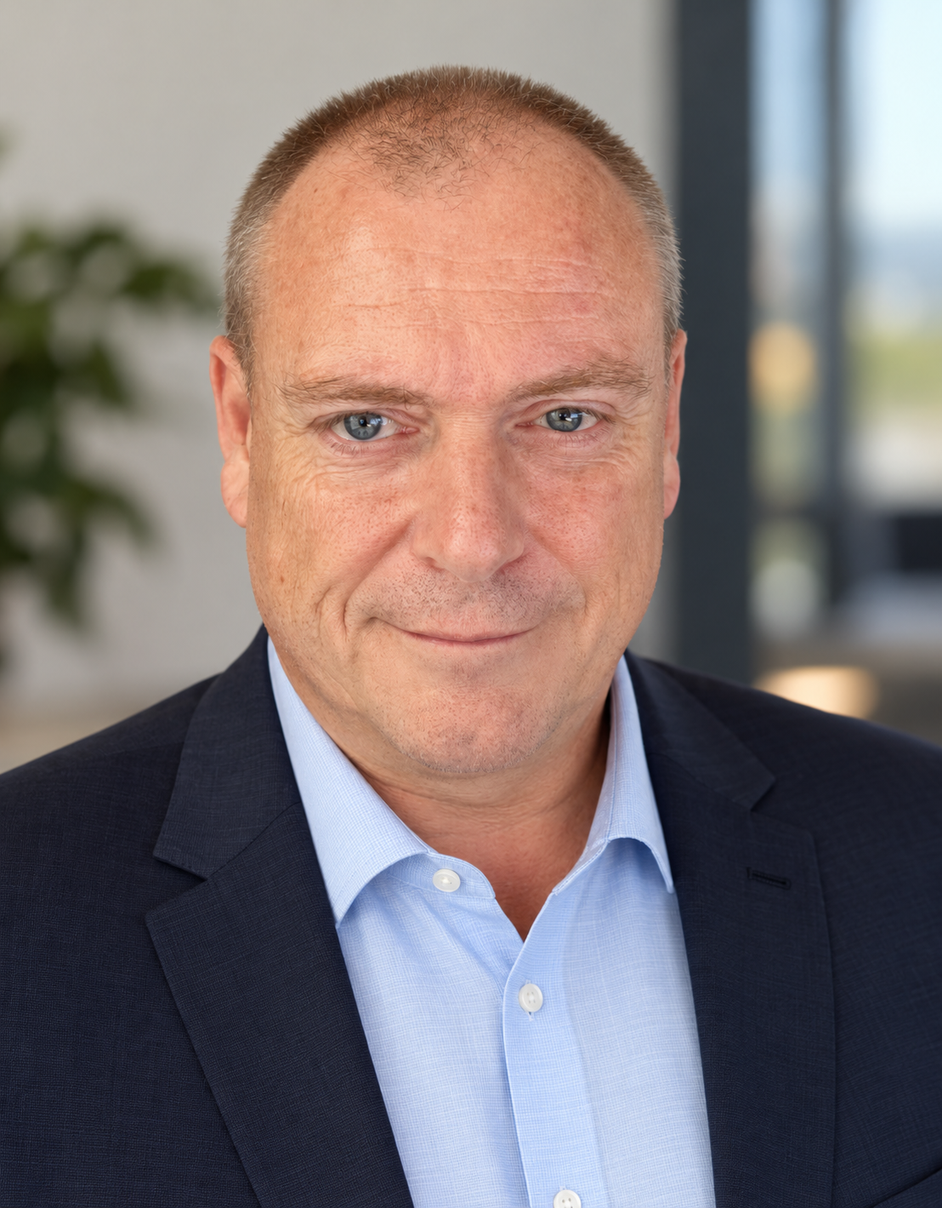 | Michael Klewer  - Microsoft 365 Architect / IT Senior Consultant
  ✆ +49 (0) 2421-3059509 | @ info@mklewer.com
  ◎ worldwide / on-site & remote | ↗ mklewer.com · LinkedIn
PROFILE
Microsoft-certified, independent Senior Consultant and Microsoft 365 Architect with more than 20 years of experience in national and international enterprise projects. Focused on Microsoft 365, Exchange, Active Directory/Entra ID, Endpoint Management and complex migrations. Experienced in architecture, assessments, governance, Security & Compliance as well as technical project and workstream leadership. Hands-on oriented with a focus on Zero Trust, stable operational transitions and on-time delivery.
CORE COMPETENCIES
● M 365 & Exchange Online, Migration von HCL Lotus Notes & GroupWise | ● Active Directory & Entra ID, Hybrid Identity, AD / Entra ID Assessments
● M 365 Security & Compliance, Zero Trust | ● Microsoft Intune / Endpoint Management, AutoPilot
● MFA & Conditional Access, Defender, Purview | ● MobileIron / Ivanti, Workspace One, Blackberry Enterprise Service UEM
● PowerShell & Power Automate | ● SharePoint, OneDrive & Teams
● PKI, Certificates & SAML | ● Windows Server 2000–2025 / Exchange Server 2000–2019 & SE
● Virtualization: VMware, Hyper-V, Azure VDS/VDI, Proxmox | ● ITIL, ServiceNow, Jira, Confluence, Veeam, MS Project & Visio
● Software: Windows 11, Windows 365, macOS, Linux, MS-Office | ● Hardware: HP-/Dell-Server, Apple Devices, Laptops, Cellphones, Tablet’s
SELECTED PROJECT EXPERIENCE
06/2026 – 08/2026 | Senior Consultant – Microsoft 365 Implementation  City of Wuppertal · Wuppertal, Germany · Remote  • Planning and implementation of Microsoft Entra ID, Exchange Online and Intune, including integration of existing on-premises systems.  • Design of a secure Microsoft 365 infrastructure and preparation for data protection, compliance and audit requirements for public administration,  fire services and schools in North Rhine-Westphalia.
05/2026 – present | Senior Consultant – Active Directory & Governance  MetPro Verpackungs-Service GmbH · Jesewitz, Germany · Remote  • Analysis and administration of the operating environment: users, licenses, groups, policies, Entra ID, MFA, Conditional Access, and lifecycle and  compliance management with Intune.  • Microsoft 365, Enterprise Applications, SAML, certificates/PKI, PowerShell/Power Automate, SharePoint, and network/security infrastructure;  documentation.
04/2026 – present | Senior Consultant – Active Directory & Governance  Hewlett Packard / SPAR AG · Vienna & Salzburg, Austria · Remote  • AD assessments in preparation for an Active Directory trust; documentation of security-relevant findings and creation of a remediation action plan.
11/2025 – 03/2026 | Senior Consultant – Exchange / SMTPeter  CompuGroup Medical Deutschland AG · Koblenz, Germany · Remote  • Introduction of mass-mailing packages in SMTPeter and Azure; verification of SPF, DMARC and DKIM and implementation of affiliated companies;  documentation.
09/2025 – 12/2025 | Senior Consultant – Active Directory  Saxony-Anhalt Judiciary · Germany · On-site & Remote  • Consulting and design of security measures and upgrade to a current Active Directory version; documentation.
03/2025 – 10/2025 | Senior Consultant – GroupWise / Microsoft 365 Migration  digatus technology GmbH · Augsburg, Germany · Remote  • Consulting, design and execution of a GroupWise-to-Microsoft-365 migration; documentation.
10/2024 – 12/2024 | Senior Consultant / System Administrator – Active Directory  City of Krefeld · Krefeld, Germany · Remote  • Design and restructuring of Active Directory; implementation of a tiering model.
11/2023 – 10/2024 | Senior Consultant / System Administrator – Active Directory  Kindernothilfe e.V. · Duisburg, Germany · Remote  • Network coordination, Active Directory design and restructuring, and implementation of new administration software.
10/2023 – 07/2024 | Senior Consultant – Active Directory / Entra ID / Security  DSA Daten- & Systemtechnik GmbH · Aachen, Germany · Remote  • Consulting on MFA, Conditional Access and Microsoft Application Proxy; documentation.
09/2023 – 06/2024 | Lead Senior Consultant – MDM / MobileIron  Allgeier IT Services GmbH · Munich, Germany · Remote  • Design and deployment of MobileIron Core, Microsoft Intune and MDM; migration of Windows, macOS, iOS and iPadOS devices; policies, lifecycle  service, documentation and user instructions.
01/2018 – present | Lead & Microsoft 365 Architect / Senior Consultant  LCserv Corp · Bonita Springs, US + Germany · On-site & Remote  • Lead & Cloud Solution Architecture for Lotus Notes, Exchange, Office/Microsoft 365 and Azure AD/Entra ID migrations; Windows 365, Teams telephony,  Dynamics 365 and UEM/MDM.  • IT inventory and licensing; technologies including Intune, MobileIron, Workspace ONE, XenMobile and BlackBerry UEM.
04/2021 – 06/2023 | Senior Consultant – Exchange / Office 365  Altana Management Services GmbH · Wesel, Germany · Remote  • Consulting for Exchange on-premises and Microsoft 365; L3 support for Exchange Online/on-premises, Windows 365, authentication, users/groups,  compliance, security, Intune and Teams.

ADDITIONAL PROJECT EXPERIENCE
12/2020 – 06/2022 | Microsoft 365 Architect & Subject Matter Expert (SME)  Atos Information Technology GmbH / RheinEnergie AG · Wiesbaden, Germany · Remote  • Design of a migration from Active Directory to Entra ID and Exchange 2010/2016 to Microsoft 365/Exchange 2019; Teams telephony and PowerShell.  • Review of the migration concept; planning and execution of the MDM migration from Workspace ONE to Microsoft Intune, including decommissioning.
10/2020 – 11/2021 | Senior Consultant – Exchange / Office 365 Migration  LEONI AG · Nuremberg, Germany · Remote  • L3 support and troubleshooting for Exchange 2010/2016, Office 365, EOP/ATP, MobileIron, IronPort, Julia and Kemp; continuation of a migration for  approximately 30,000 mailboxes worldwide.
10/2020 – 02/2021 | Senior Consultant – Lotus Notes / Office 365 Migration  QSC AG · Hamburg, Germany · Remote  • Migration from Domino/Lotus Notes to Office 365; current-state/target-state analysis, planning and documentation.
10/2020 – 02/2021 | Senior Consultant – Exchange / Office 365 Migration  Implement-IT GmbH · St. Ingbert, Germany · Remote  • Planning and execution of an Exchange/Office 365 migration, including proof of concept and documentation.
02/2019 – 03/2020 | Microsoft 365 Architect – Lotus Notes / Microsoft 365 Migration  Gerresheimer AG · Düsseldorf, Germany + worldwide · On-site & Remote  • Lead & architecture for the migration of approximately 4,000 mailboxes from Lotus Notes to Exchange 2016/Microsoft 365/Azure AD; analysis, design, implementation and decommissioning of the Notes infrastructure.  • Migration from MobileIron to Intune; policies, lifecycle service, documentation and project planning.
06/2019 – 12/2019 | Lead & Architect – Exchange / Office 365 Migration  GES Systemhaus GmbH · Wiesbaden, Germany · On-site & Remote  • Lead & architecture for the hybrid migration from Exchange 2013 to Office 365/Azure AD; analysis, planning, preparation, implementation and project documentation.
08/2017 – 12/2017 | Senior Consultant – Exchange / MDM  LEONI AG · Nuremberg, Germany + worldwide · On-site & Remote  • L3 support for Exchange 2010, Good Secure EMM Suites, MobileIron, IronPort, Julia and Kemp; email and MDM operations for approximately  30,000 mailboxes worldwide.
01/2017 – 03/2017 | Senior Consultant – MDM  BTC AG · Oldenburg, Germany · On-site  • Proofs of concept for BlackBerry Enterprise Service (UEM) with Android AFW/Samsung Knox and XenMobile; feasibility study for in-house apps.
10/2016 – 01/2017 | Senior Consultant – Lotus Notes / Exchange Migration  Circ IT GmbH · Düsseldorf, Germany · On-site & Remote  • Migration of approximately 3,000 mailboxes from Lotus Notes to Exchange 2013 using Dell MNE; troubleshooting of the migration process and  preparation of further Exchange migrations.
11/2015 – 06/2016 | Senior Consultant – MDM  Sartorius AG · Göttingen, Germany + worldwide · On-site & Remote  • L3 support and infrastructure design for MobileIron Cloud; security requirements, Office 365 migration, system cleanup and worldwide device rollout.
03/2015 – 10/2015 | Senior Consultant – MS Exchange / MDM  Evonik Industries AG · Frankfurt/Main, Germany + worldwide · On-site & Remote  • L3 support for MobileIron, BlackBerry Enterprise Server and iOS/BlackBerry with Lotus Notes; preparation of a migration to Exchange 2013/Office 365  and SharePoint.
02/2015 – 03/2015 | Senior Consultant – MS Exchange  City of Hanau, IT Service Center · Germany · On-site  • Analysis of an Exchange 2010 infrastructure, error assessment and corrective recommendations in preparation for Exchange 2013.
01/2011 – 12/2014 | Consultant – MS Exchange / MDM  Deutsche Telekom AG · Darmstadt, Germany · On-site & Remote  • Exchange 2003/2007/2013/Office 365 migration for approximately 6,000 mailboxes; SharePoint 2013; BlackBerry Enterprise Server;  Windows Server/Active Directory.  • Multi-domain Kerberos/trusts, OU reorganization, MobileIron, client/device rollout, VMware and Citrix test environments; led a team of 5 employees.
CERTIFICATIONS
• Microsoft Certification MCSA
• Microsoft International Certification MCSE (US)
LANGUAGES & WORKING STYLE
German: native · English: professional · Availability: worldwide, on-site & remote
Strengths: Communication · Management · Organization · Leadership · Teamwork · Creativity · Process Monitoring
REFERENCES
Altana Management Service GmbH, Wesel · Marc Böing ·  marc.Boeing@altana.com · +49 (0) 281-67010263 | Atos Information Technology GmbH, Düsseldorf · Michael Bursch · michael.bursch@atos.net · +49 (0) 211-39938037
Gerresheimer AG, Düsseldorf · Holger Anspach ·  h.anspach@gerresheimer.com · +49 (0) 211-6181252 | Leoni AG, Nürnberg · Philipp Getzinger ·  philipp.getzinger@leoni.com · +49 (0) 911-2023230

